Chapter 11, Solution 85.

A regular household system of a single-phase three-wire allows the operation of both 120-V and 240-V, 60-Hz appliances. The household circuit is modeled as shown in Fig. 11.96. Calculate: (a) the currents I₁, I₂, and I_{n}, (b) the total complex power supplied, (c) the overall power factor of the circuit.

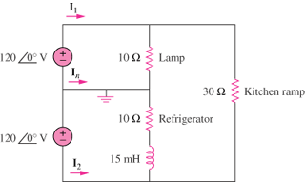

Figure 11.96
For Prob. 11.85.

Solution

(a)
We apply mesh analysis as shown below.

I₁

+
I_{x}
120<0º V 10
-
I_{n}
30
I_{z}

+ 10
120<0º V I_{y}
-

j5.655
I₂

For mesh x,
120 = 10 I_{x} - 10 I_{z} (1)
For mesh y,
120 = (10+j5.655) I_{y} - (10+j5.655) I_{z} (2)
For mesh z,
0 = -10 I_{x} –(10+j5.655) I_{y} + (50+j5.655) I_{z} (3)
Solving (1) to (3) gives
I_{x} =20, I_{y} =17.09-j5.142, I_{z} =8
Thus,
I₁ =I_{x} =20 A
I₂ =-I_{y} =-17.09+j5.142 = = 17.85∠163.26° A
I_{n} =I_{y} - I_{x} = –2.91 –j5.142 = = 5.907∠–119.5° A

(b)

(c ) pf = P/S = 4451/4494 = 0.9904 (lagging)

